
St Aloysius College (Autonomous)
Mangaluru

Criterion St Aloysius V:
Student College Support (Autonomous)and Progression
Mangaluru

Metric Criterion No.: I5.:1Curricular.5 Aspects
Year: 2022-2023

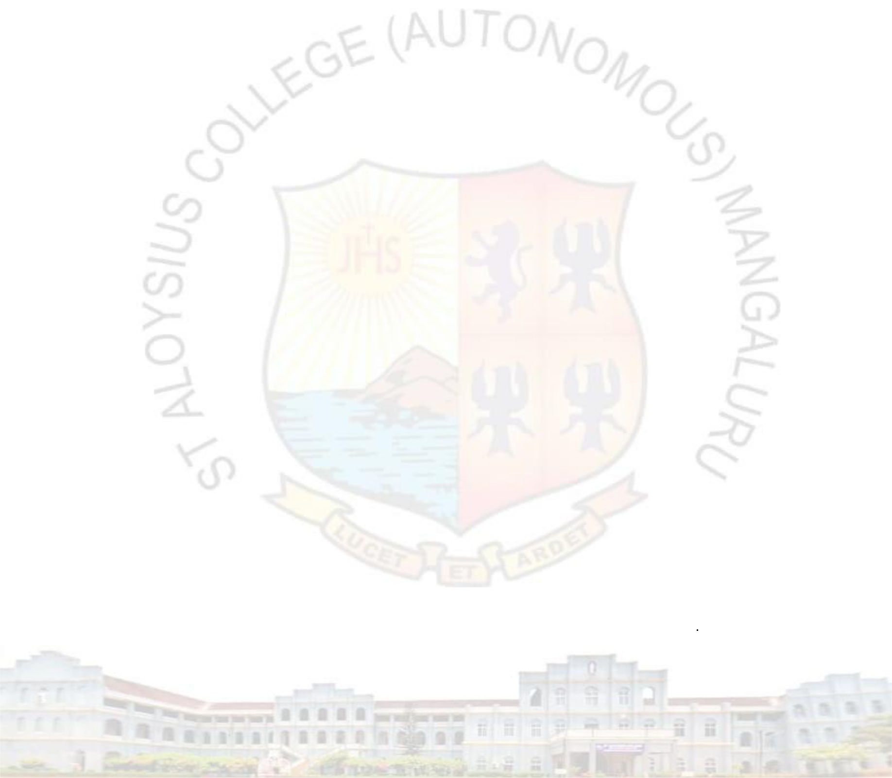
Department of postgraduate studies and research in economics net coaching 2022-23

DEPARTMENT OF POSTGRADUATE STUDIES AND RESEARCH IN ECONOMICS NET COACHING 2022-23 Department of Postgraduate Studies and Research in Economics conducted 20 hours of NET coaching for this Academic year 2023-24. 26 students participated in the coaching. Mr Olwin M Dsouza, Dr. P.P. Sajimon, and Dr. Florin Soans dealt with subject papers. Mr. Olwin M Dsouza was the coordinator of the coaching. The coaching was conducted on Monday 2-3 pm, Wednesday 1-2 pm, and Friday 3-4 pm.
The following students benefitted from the coaching:

Sl. No. | Reg No. | Name of the Student
 | 229801 | ANN MARY ROY
 | 229802 | ARAMALLA SANDHYARANI
 | 229803 | ATHUL MICHAEL
 | 229804 | EMPRISH R MARAK
 | 229805 | ISHA FATHIMA HUSSAIN K V
 | 229806 | JETHIN ADITYA JOHN
 | 229807 | MAJO JOHNY
 | 229808 | MEENAJ MAHAMMADARAFIK DONOOR
 | 229809 | MOHAMMAD HAFIL
 | 229810 | MUTHAMMA T T
 | 229811 | PAUL CHRISTOPHER D COSTA
 | 229812 | PRATHIBHA BALAPPA DODAMANI
 | 229813 | ALEENA BIJU
 | 229814 | DIYA ELZ JOSE
 | 229815 | SHYNI DELISHA MONTEIRO
 | 229816 | OSAMA HASAN
 | 219801 | AJAL MARIYA
 | 239801 | Anshika
 | 239802 | Athul
 | 239803 | Basamma
 | 239804 | Josna
 | 239805 | Nahla
 | 239806 | Niona
 | 239807 | Premalatha
 | 239808 | Shabiya
 | 239809 | Aneena

